The life of the South Equatorial Disturbance, 1999-2010

John Rogers
(British Astronomical Association) (using data from the JUPOS team:
Hans-Joerg Mettig, Michel Jacquesson, Marco Vedovato, & Gianluigi Adamoli)

Since 1999 we have reported the origin and continued existence of the South Equatorial Disturbance (SED) (refs.1-4). In ref.3 we gave a complete history of it up to 2005. In ref.4, the further history up to 2010 was summarised; but as this was not the main focus of that paper, we give a more complete account here. Also, whereas Ref.4 used conventions for orientation of figures which are the opposite of our usual ones, here we illustrate it with images and charts in our usual convention of south up and east the left. This summary was compiled in 2011 Oct. and finalised for posting in 2012 August. Further details have been given in interim reports posted for each apparition on our web site.

The South Equatorial Disturbance (SED) is a large wave-like feature at ~7ºS, with complex and variable appearance (ref.3 & Fig.1). At times it is conspicuous or ‘active’, with a distinct bright ‘rift’ through the SEBn; spacecraft imaging at these times has revealed a large anticyclonic oval in the southern EZ, which is sometimes very bright. At other times the SED is inconspicuous or ‘quiescent’, but is still marked by a bright strip in southern EZ alongside a persistent blue-grey streak near the equator. These two aspects are associated with different dynamics on the SEBn jet stream (refs.3,4).

Because of the variable appearance, a variety of techniques have been needed to track the SED over the years. We have visually identified it in each year, defining its longitude as that of the discontinuity in the SEBn, and kept track of it by measuring it specifically on many images. We have also tracked it using the JUPOS database. In the routine JUPOS charts, it does not appear as a simple feature track becasuse of its complexity, but its track can be seen unambiguously as follows:
(i) when it is conspicuous, a zone of low density of chevrons, with an obvious boundary against a high-density region to the east (p.). The chevrons arise near this boundary, ~10-20º E of the SED.
(ii) when it is not conspicuous, the west (f.) end of a blue-grey streak in southern EZ (alongside a white strip).
Although such features would not appear notable in isolation, their association with the SED is evident because they are unique and persistent and align well with the track of the visually identified SED. Here we present synoptic JUPOS charts (prepared by Hans-Joerg Mettig and thr JUPOS team), with the track of the visually identified SED overlaid.

1999-2005:
The changing appearance and dynamics of the SED were described in refs.1-3. The synoptic chart was published as Supplementary Online Material with ref.3, and is repeated here as Fig.2 with the track of the visually identified SED marked in purple. The main chart shows dark spots at 5-8ºS (almost all being chevrons, showing the density boundary); the inset shows f. ends of dark streaks at 3-6ºS. The black arrows on the figure connect up tracks between apparitions, either from the chevron density boundary, or from the f. end of the streak.

Sources of SED tracks:
1999/2000: Visually identified SED: Our published report [Rogers et al., 2003; JBAA 113,10]
2000/01 and 2001/02: Visually identified SED: Our published report [Rogers et al., 2005; JBAA 115,70]
2002/03: F. end of the streak from the inset chart.
2003/04: Visually identified SED.
2004/05: F. end of the streak from the inset chart.
In the years when the f. end of the streak was the main marker, note that the boundary of chevron density was also still visible although more subdued.
To demonstrate that the f. end of the blue-grey streak is indeed a consistent marker for the SED, which can be recognised in its quiescent state when hi-res images are available, we show a set of images from 2005 (Fig.3).

2006-2010:
To show that the SED persisted similarly up to 2009/2010, we show the JUPOS charts for these years (Fig.4), and the same with the visually identified SED marked in purple (Fig.5). Again, SEBn and EZ(S) are shown separately. The scales are different from Fig.2, and Fig.5 shows bright features (red points) as well as dark features (black points).

Sources of SED tracks:
2003/04: Visually identified SED (individual measurements are shown). The SED was conspicuous with its classic structure as reported in ref.3.
2005: F. end of the streak from the EZ(S) chart. The SED was inconspicuous but still tracked (e.g. Fig.3). The SEBn jet showed maximum speed at all longitudes (ref.3).
2006: Visually identified SED (individual measurements are shown). One panel has been posted in a short interim report:
http://www.britastro.org/jupiter/2006report09.htm
In this year, grey-brown shadings were accumulating in the EZ, so that the SED, the chevrons, and the EZ(S) streak were all difficult to see, and the SEBn jet speed coiuld not be measured. However the SED was visible on each passage past the GRS. At the passages in April and June, it was close to its original track, but it then shifted ~35-40 deg. east before the next passage in July, and again ~25-30 deg. east before the next passage in Sep. The limited and reproducible range of these offsets, and the classic form of the SED observed after them, suggests that they were shifts of the existing SED, not new features, and indeed the chart suggests that the SED may have reverted to the original track during solar conjunction.
It is unambiguous that in the following year:
i) When New Horizons imaged it in 2007 Jan., the SED was again a conspicuous feature very close to its original track, with its classic outline indicating anticyclonic circulation.
ii) During 2007, the main complex again shifted 30 deg. east and then progressively reverted to its original track, all being documented in detail as noted below, supporting the reality of similar events in 2006.

2007: Visually identified SED (pair of Great White Spots: tracks delineated from the JUPOS chart and from individual measurements). There was still extensive dark shading in the EZ, but the SED had become very conspicuous, displaying its classic structure as a Great White Spot. As it passed the GRS in mid-Feb., the SED duplicated, with a new main complex developing 30 deg. east of the existing one. The old one gradually faded away, while the new one was a spectacular SED. In June, it decelerated and expanded westwards, becoming a huge white lozenge >30 deg. long., which eventually re-formed a classical main complex exactly on the original track. Thus, the shift east was only temporary and the SED resumed its original track. A detailed report has been posted:
http://www.britastro.org/jupiter/2007report19.htm
Chevrons had the same range of speeds as in previous years when the SED was conspicuous, but with exceptional variability east of the SED, which masked the usual longitudinal gradient of the SEBn jet.
2008: Visually identified SED. (Track plotted by Gianluigi Adamoli & JHR.) The SED was conspicuous, as illustrated in the ref.4. The longitudinal gradient of chevron speeds was very clearly shown (see ref.4, and our final report nealy posted in ‘Reports – 2008’).
2009: F. end of the streak from the EZ(S) chart (blue line), and centre of the white strip (purple line: JUPOS measurements plotted by Michel Jacquesson). Also, the chevron density boundary is again evident although subdued. The SED was quiescent throughout 2009, but clearly visible (Fig.6a). Many chevrons were tracked, esp. p. the SED, and had a constant, unusually slow speed of DL1 ~ -90 deg/mth at all longitudes.
2010: Probably still visible in 2010 May (Fig.6b), as in 2009, but not thereafter. It disappeared as the SEB was fading, and did not reappear in the 2010 SEB Revival.

In conclusion, the SED has been unambiguously tracked as a unique feature in ground-based observations from 1999 to 2009.

The history of the SED gives further credence to the idea that it is sustained by energy from the convective (‘rifted’) regions of the SEB. It has long been suspected that the short-term revivals of the SED after it passes the Great Red Spot (GRS) were due to interaction with the convective region f. the GRS. Longer-term variations in the visibility of the SED also seem consistent with its being sustained by similar interactions over a broader region, as follows (from refs.3 & 4). In addition to the continuous activity west of the GRS, there have been mid-SEB outbreaks of bright convective storms in 1998, 2003, 2005, 2007 (the SEB Revival), and 2008. Resurgences of the SED in 2004 and 2006 followed the mid-SEB outbreaks in 2003 and 2005. The SED remained prominent in 2007 when the SEB activity stopped, possibly because the subsequent SEB fading lasted only a few months before the SEB Revival began with its intense convective storms. The SED was strong again in 2008 as the SEB Revival was followed by extensive mid-SEB outbreaks, and it was visibly connected to them by a bright cloud streak on several occasions. However, it became quiescent after passing the GRS in 2008 Oct., and was never again a prominent feature. In 2009, the SEB convective activity stopped completely and the SEB quickly began fading (whitening). The SED then finally disappeared in 2010, as the SEB fading proceeded. (The same had occurred in 1989, with a long-lived SED disappearing as the SEB faded.)

Therefore the birth, lifetime variations, and death of the SED were all broadly consistent with dependence on convective activity in the SEB, with a lag of ~6-12 months. This lag would consist mainly of the time for changes in mid-SEB activity to spread to the northern part of the belt; the actual response of the SED is probably much faster. However, the correlation is only qualitative, and we do not yet know what the physical process involved might be.

If the SED is a solitary wave (refs.3,4), one may suggest that its variable aspect depends on the amplitude of the wave, which is governed by the varying supply of energy from convective outbreaks in the SEB. When the wave is driven to high amplitude, the SED becomes conspicuous, with a strong anticyclonic circulation and strong suppression of the jet stream downstream from it. When it has low amplitude, the SED still exists but is visually inconspicuous and does not have these large dynamical effects.

References for our papers on the SED:

(1) Rogers J, Mettig H-J, Peach D & Foulkes M (2003), JBAA 113 (no.1), 10-31.
‘Jupiter in 1999/2000, Part I: Visible wavelengths.’
(2) Rogers JH, Cidadão A, Akutsu T, Mettig H-J, Peach D, Orton GS, JBAA 115 (no.2), 70-78 (2005). ‘Jupiter in 2000/2001: Part III: The South Equatorial Disturbance: A large-scale wave in a prograde jet.’
(3) Rogers JH & Mettig H-J. (2008), ‘Influence of Jupiter's South Equatorial Disturbance on jet-stream speed’. JBAA 118 (no.6), 326-334.
(4) Simon-Miller AA, Rogers JH, Gierasch PJ, Choi D, Allison MD, Adamoli G, Mettig H-J (2012). ‘Longitudinal variation and waves in Jupiter’s south equatorial wind jet.’ Icarus 218, 817–830. [doi:10.1016/j.icarus.2012.01.022]
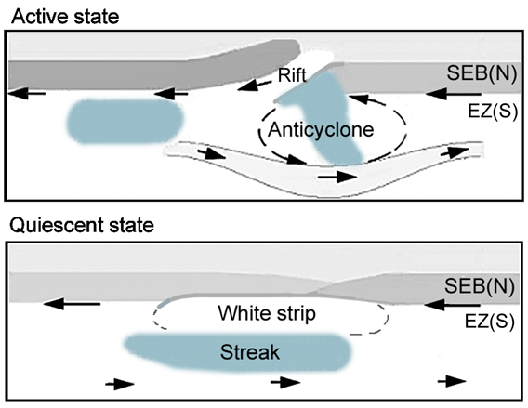

Fig.1: Diagram showing typical appearances of the SED. South is up.

Fig.2 [next page]: JUPOS chart tracking the SED, 1999-2006.
Reprinted from the Suppl. Online Material of Ref.3, plus tracks marked for the visually identified SED.
Main chart: Latitudes -5.0 to -8.0. Longitude scale moves at +0.70º/day in System I
(-6.6633º/day in System III; +95.5 m/s for 7.3ºS). Diagonal blue lines indicate L1 = 0.
Only dark features are shown.
+ = spot (mostly chevrons); <-- > streak; < > p.(E) and f.(W) ends.
Time runs downwards, and longitude increases to the right, for consistency with maps that have south up, in accord with our standard convention.
Inset: Latitudes -3.0 to -6.0, on same scales, showing only f. ends of dark streaks in EZ(S).
The black arrows connect up tracks between apparitionsOverlaid in colour are the tracks for the visually identified SED (purple) or the f. end of the grey streak (blue, from the inset chart). Dashed purple lines connect up the SED track between apparitions; this track is ~10-20 deg. W of the boundary in chevron density.
The SED longitude was measured as the deepest point of the ‘bay’ in SEBn, and/or the p. end of darker SEB(N) (just f. the rift), which is normally at about the same point; and/or (when the SED is inconspicuous) the f. end of the blue-grey streak in southern EZ, which lies alongside it. These reference points all generally lie within <~10º of each other, within the SED; any spread or scatter between them is within the range of short-term variation of the SED, and is insignificant on the scale of the tracking that we report.
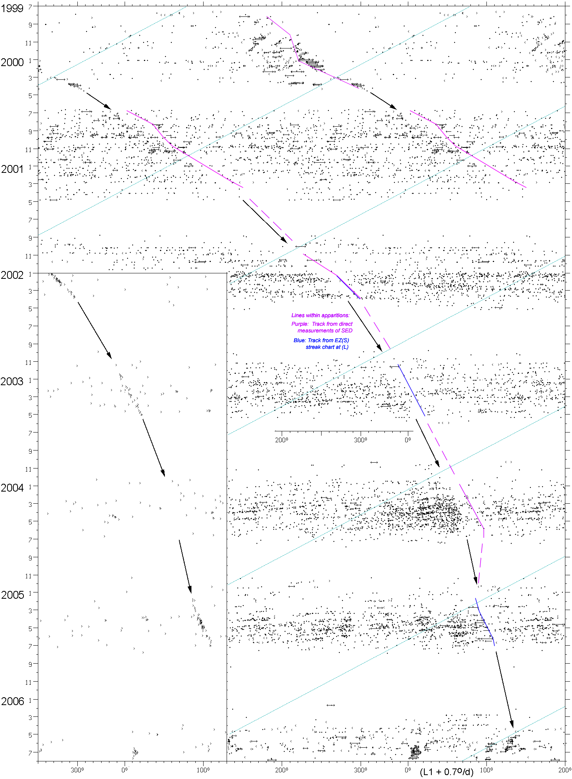

Fig.2 [caption above].
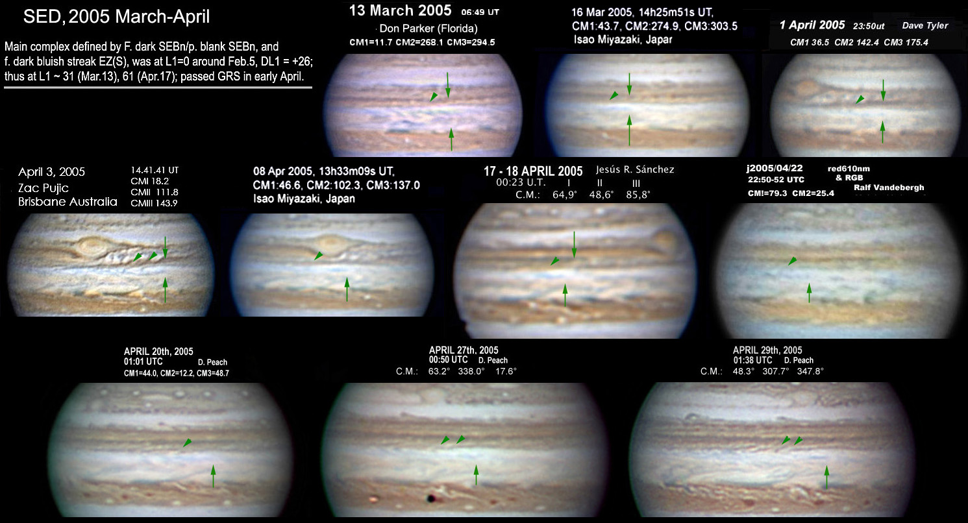

Fig.3. Images in 2005 March-April, showing the SED in its quiescent aspect. South is up. Green arrows indicate components of the SED: Arrow above, p.end of dark SEB(N); arrow below, f. end of blue-grey streak in EZ(S); oblique arrowhead, p. end of long bright white strip.

Fig.4. JUPOS chart, 2004-2010 [next page].
This is arranged like Fig.2 although the scales are different.
The longitude scale moves at +1.0 deg/day relative to System I (-6.3633º/day relative to System III, or +91 m/s for 7.3 deg.S). Time runs downwards with the start of each year marked.
The faint diagonal light blue line indicates 0° longitude in Sys. I.
Left, latitudes -3.0 to -6.0; note the well-tracked f. end of dark streak (>) in 2005 and 2009, which coincides with the SED (and a short-lived feature in 2006 which was unrelated).
Right, latitudes -5.0 to -8.0; as in Fig.1, dark spots are almost all chevrons.

Fig.5 [next page]. [Fig.5 is the same as Fig.S2 in Ref.4, but in opposite orientation. A full-resolution version can be supplied on request.]
(L) Same as Fig.4 but showing bright spots (red points) as well as dark spots (black points), and with the tracks marked for the visually identified SED (purple, as described in the text) or the f. end of the grey streak (blue, from the inset chart). In 2007, the overall extent of the Great White Spot is shown by mauve shading. Dashed purple lines connect up the SED track between apparitions.
(R) Some of the best images in each apparition. South is up.
(The HST images from 2009 Sep.18-19, one of which is shown here, are the only spacecraft views ever obtained of it in its quiescent state.)
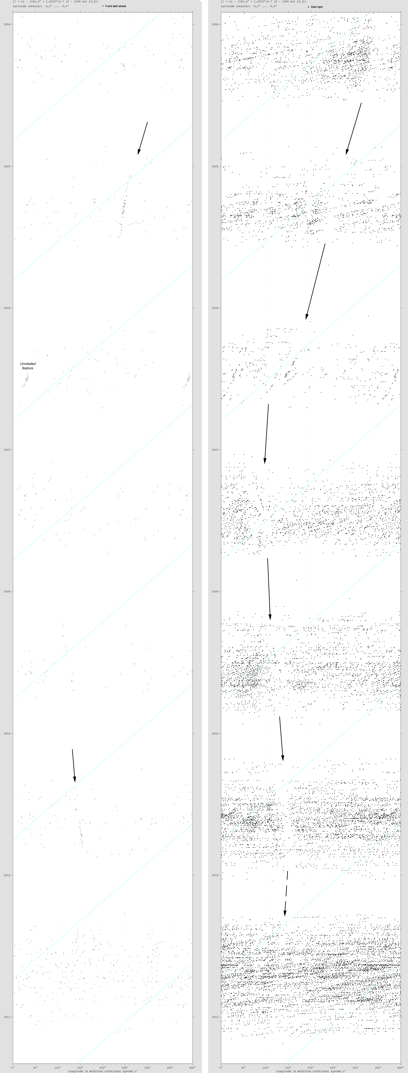 Fig.4 [caption above]
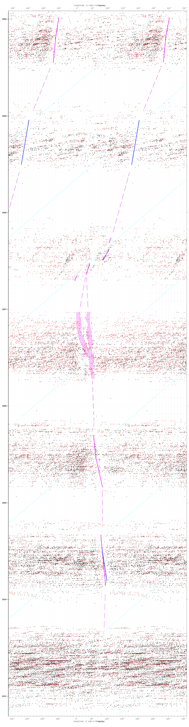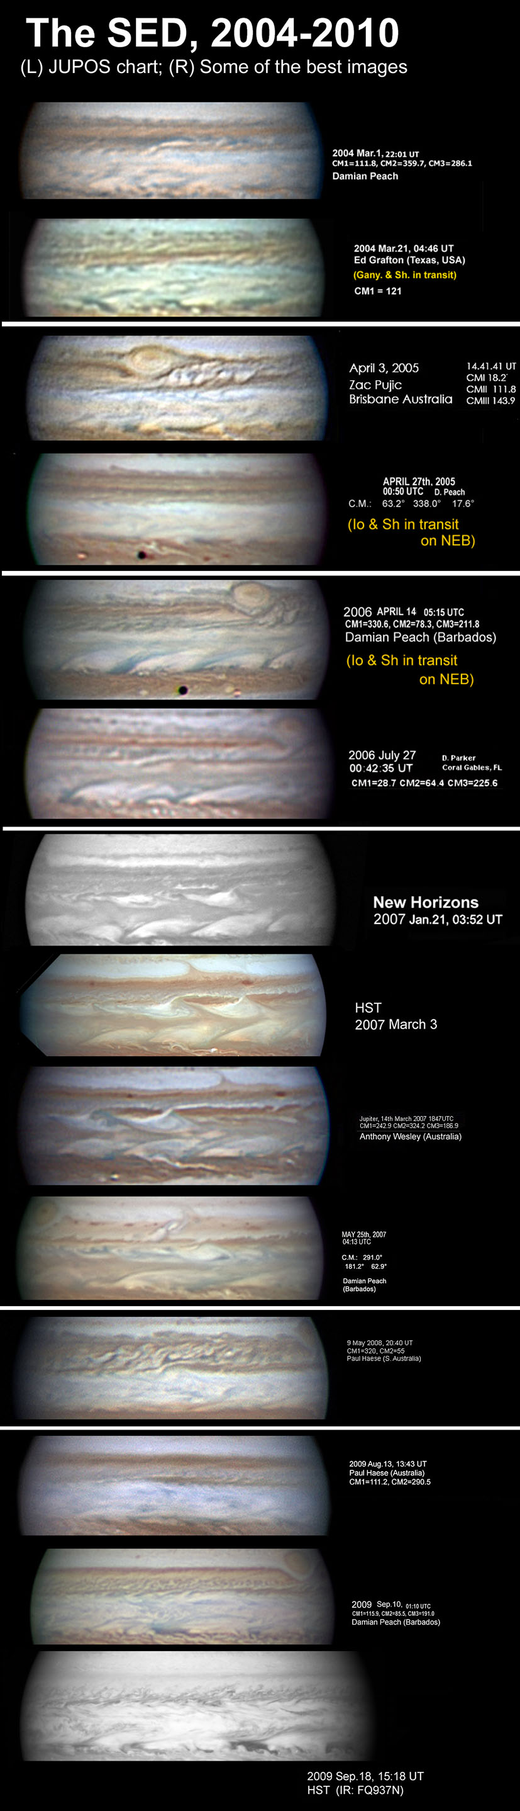
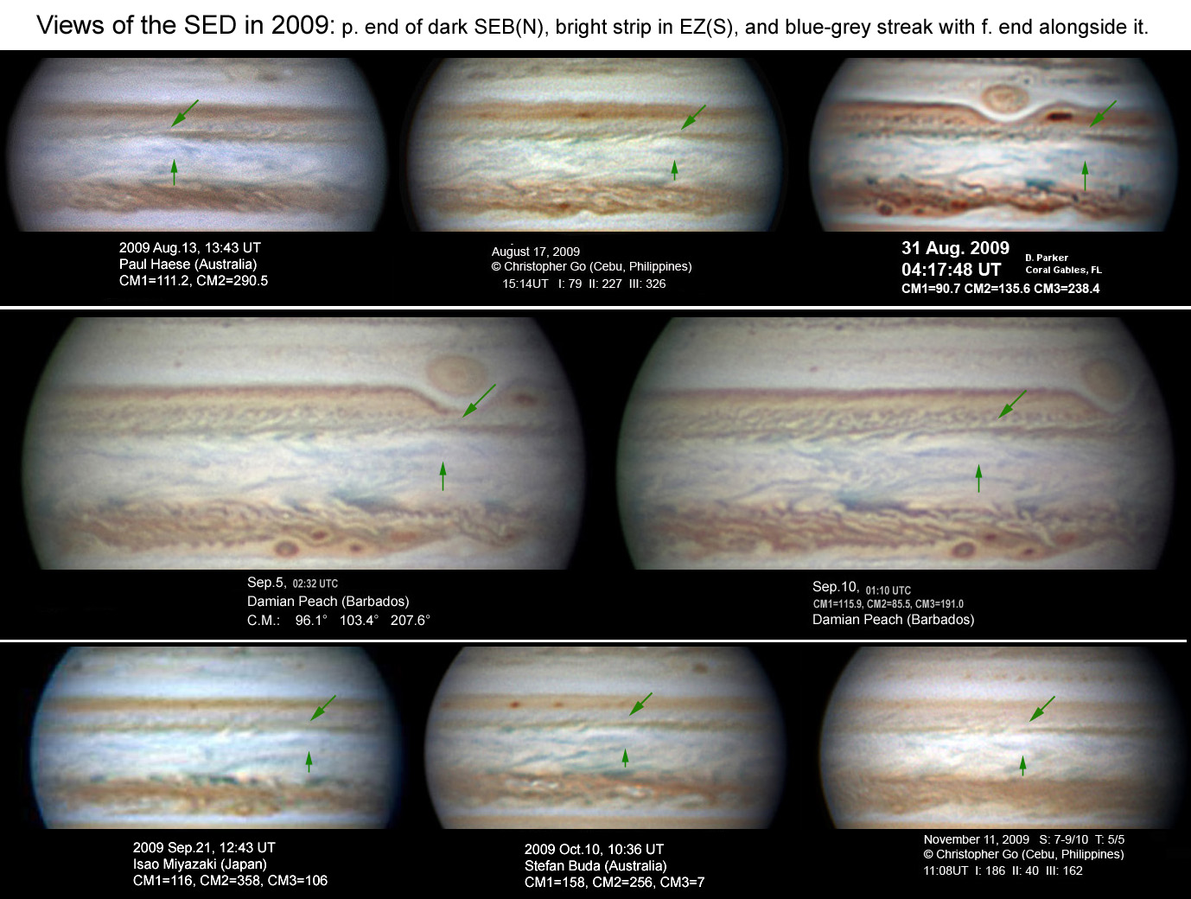

Fig.6a. Images in 2009 showing the SED in its quiescent state. South is up. Green arrow above indicates the p. end of dark SEB(N), approx. coinciding with the f. end of the brilliant white strip and the f. end of the blue-grey streak in EZ(S) (gree arrow below).

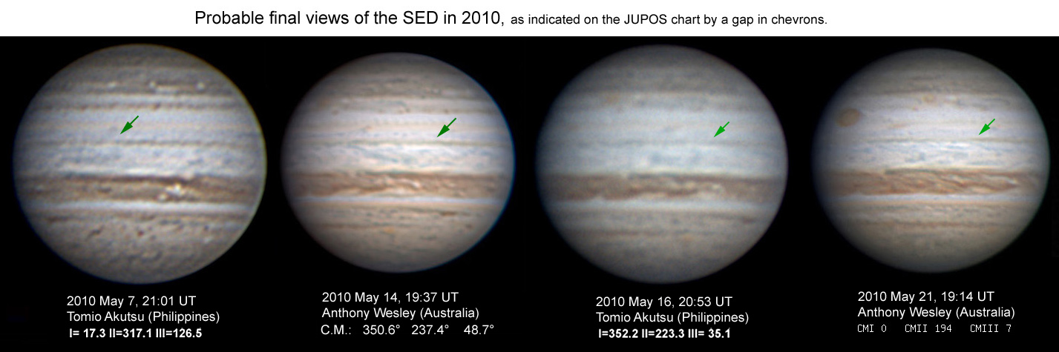

Fig.6b. Images in 2010 May which are probably the last views of the SED (green arrow).

