Report no.22 (final, 2011 April 6):
Jupiter’s SEB Revival in 2010/11: Analysis of the early stages of the southern branch

John Rogers (British Astronomical Association)
with data from Hans-Jörg Mettig, Gianluigi Adamoli, Michel Jacquesson & Marco Vedovato (JUPOS project).

Figure legends
__________________________________________________________________________

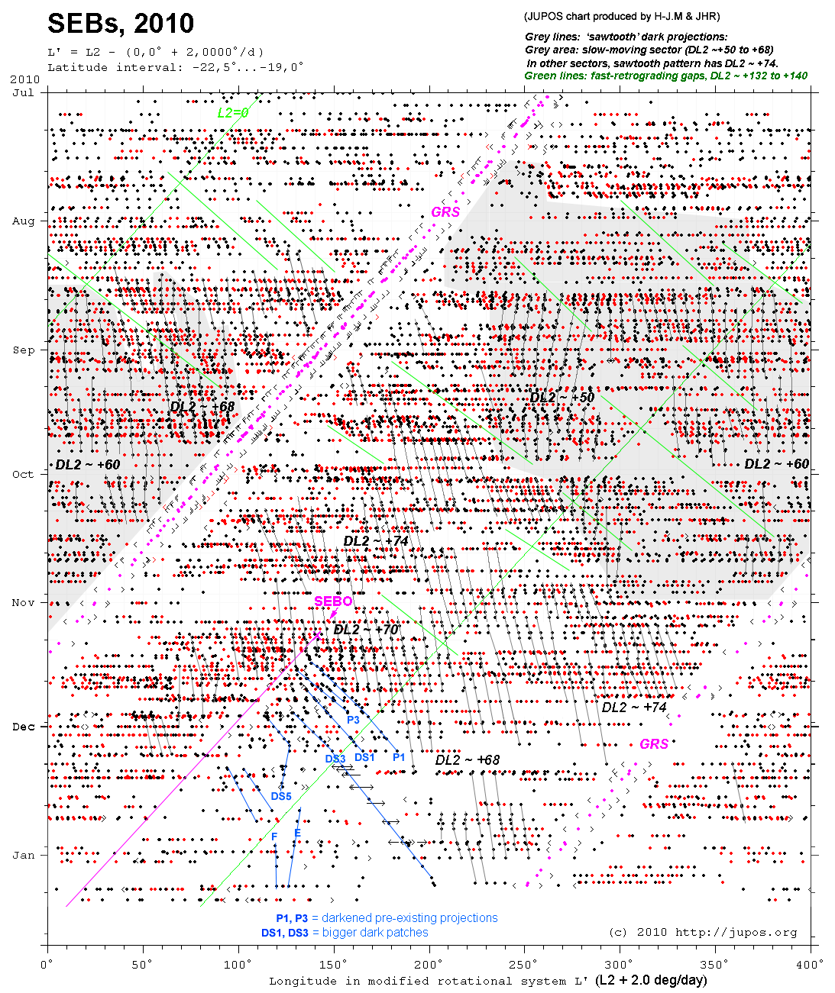

Fig.1. JUPOS chart [from H-J.M.] showing the motion of the chain of spots on SEBs before and during the Revival. All dark spots (black) and bright spots (red) on the SEBs (latitude band -22.5 to -19.0 deg.S), in a longitude system moving at +2.0 deg/day relative to System II. Grey lines indicate tracks of the dark projections. (The chart is not fully annotated for July-August as this was shown in our earlier report.) The grey area is the slow-moving sector with DL2 ~ +50 to +68; in other sectors the chain had DL2 ~ +70 to +75. Green lines indicate fast-moving gaps with DL2 ~ +132 to +140. Blue lines and labels indicate the first dark spots in the southern branch of the SEB Revival, after the initial outbreak (SEBO).

Fig.2. JUPOS data – Enlargement of the SEB Revival region using same data as Fig.1, re-plotted by JHR using Excel, in a longitude system moving at +3.0 deg/day relative to System II. Spots are colour-coded by latitude, allowing spots in slightly different latitudes to be distinguished. [This figure has been transferred to report no.21.]

__________________________________________________________________________

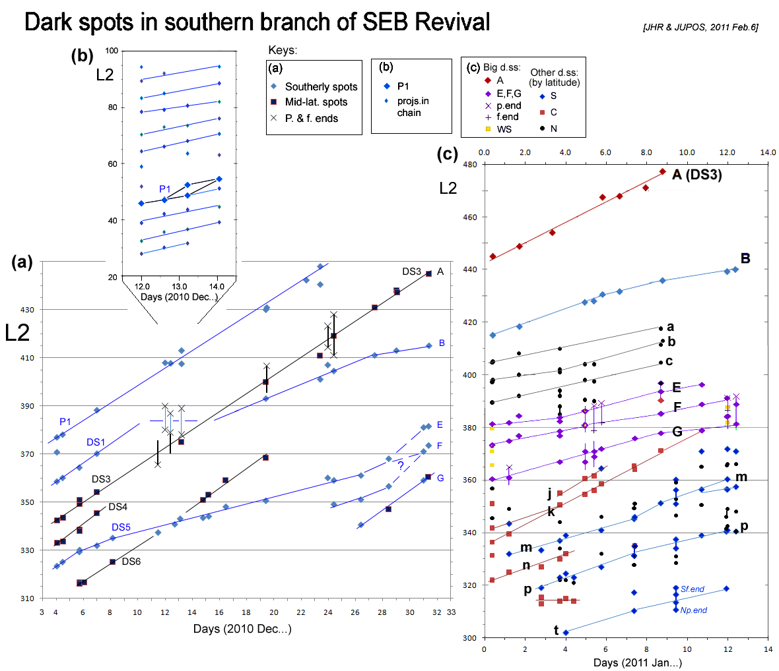

Fig.3. Charts of identified dark spots, consisting of selected JUPOS data plus additional measurements as indicated on the images, plotted by JHR using Excel. This allows all the spots to be tracked (and identifications to be checked). (a) Dark spots in Dec. (b) Enlarged sector in mid-Dec. showing dark spot P1 and the complete chain of grey projections. (For greater accuracy, CM longitudes were corrected based on measurements of 4 stable large ovals in other latitudes.) (c) Dark spots in Jan.(and a few white spots, shown yellow).

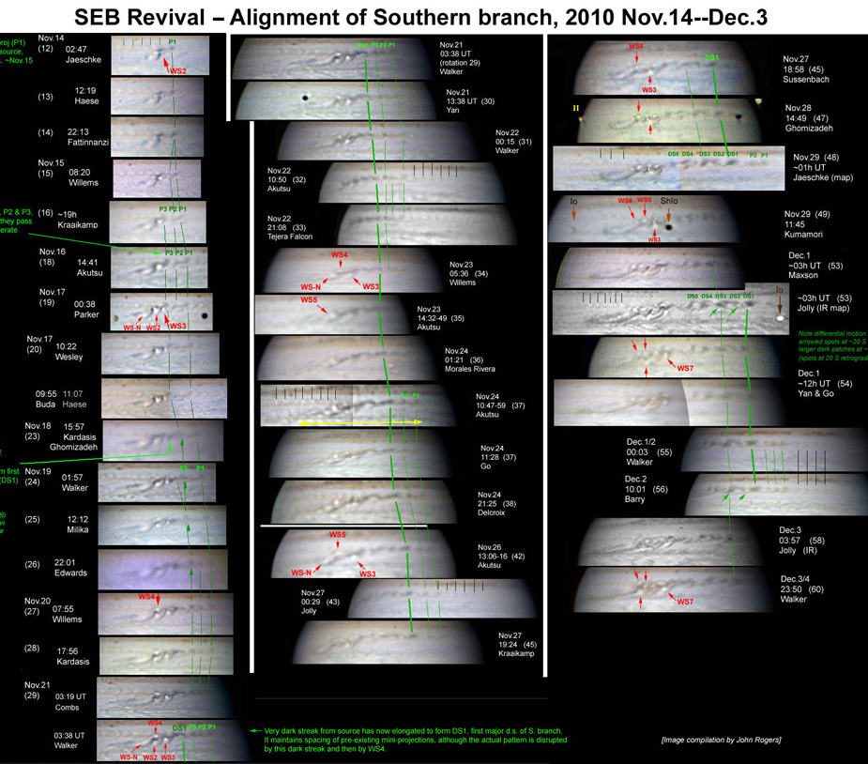

Fig.4. Images of the source and S branch, 2010 Nov.14-Dec.3.
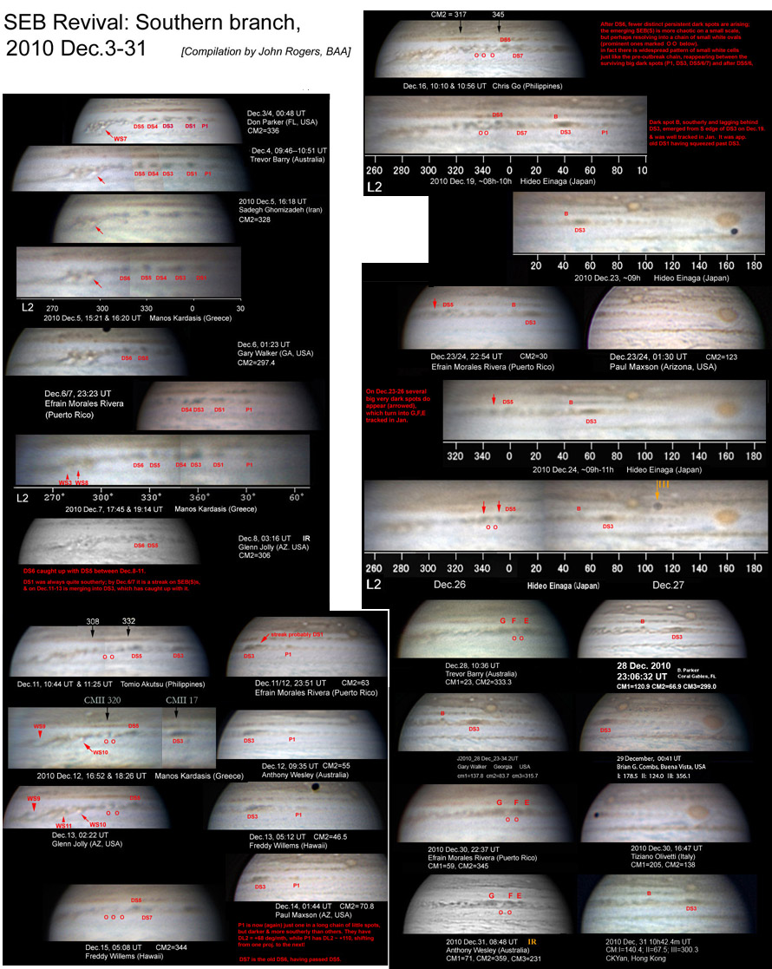

Fig.5 . Images of the S branch, 2010 Dec.3-31.
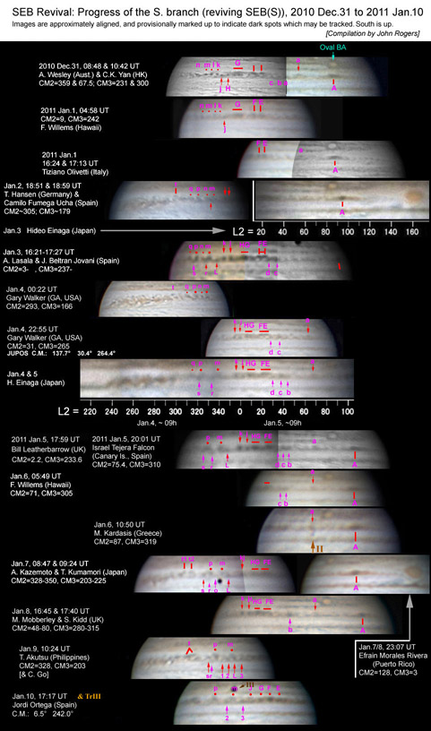

Fig.6. Images of the S branch, 2011 Jan.1-10.
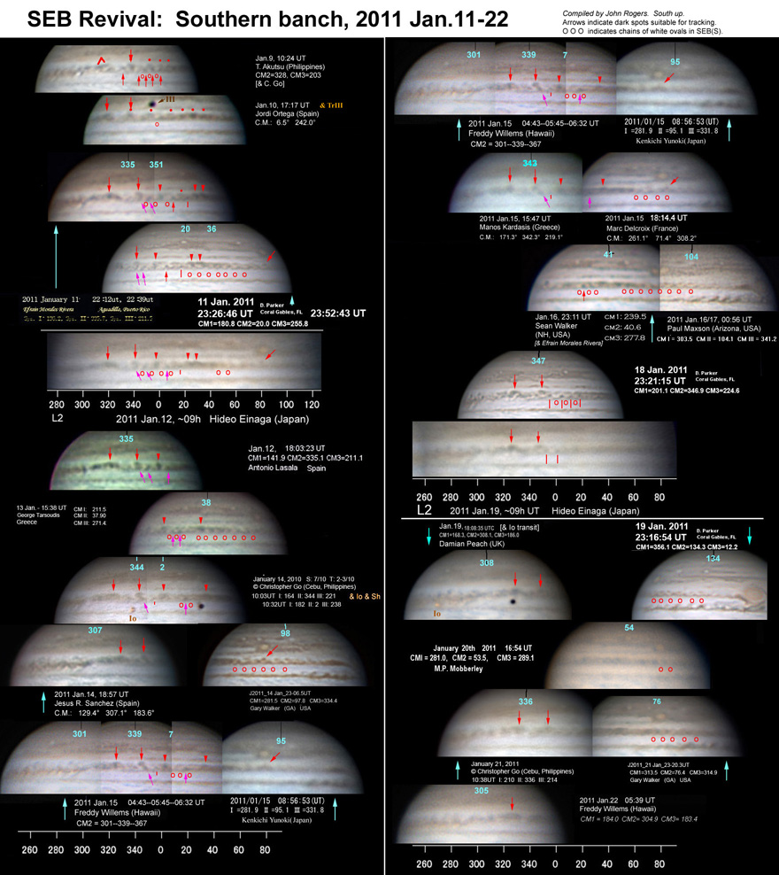

Fig.7. Images of the S branch, 2011 Jan.11-22 (not yet measured).

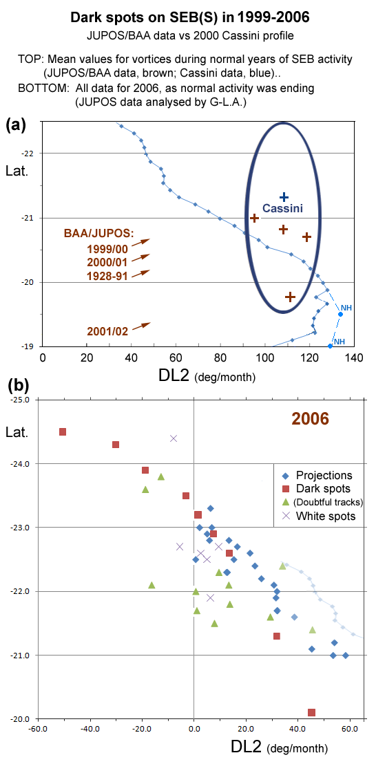
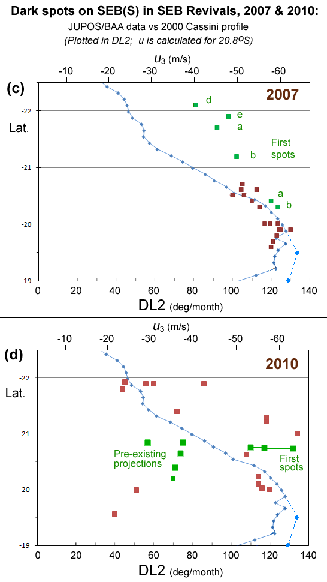
Fig.8. Charts of speed (DL2) vs latitude (zenographic) for SEB(S) spots.
(Scale of wind speed u₃ is calculated for 20.8 deg.S.)
(a): Mean values for vortices during normal years of SEB activity (JUPOS/BAA data, brown; Cassini data, blue):
--1928-1991 (mean from Rogers book; inc. SEB Revivals as well);
--1999-2002 (BAA reports, from JUPOS data)
--2000 (Cassini: approx. centre & N-S extent of vortices, estimated from publicly released maps).
Blue line: Cassini zonal wind profile (Ref.2); plus 2 additional points from New Horizons (Ref.3).
(b) 2006, when normal activity was ending (JUPOS data analysed by G-L.A., unpublished, plotted by J.H.R.)
(c) 2007: The SEB Revival: data already published on our web site [Ref.1]. (Green:) The first substantial spots (recently re-analysed by JHR, confirming the original results with greater precision). (Brown:) Later spots.
(d) 2010: The SEB Revival and pre-existing chain: data from Table 1. (Green, left:) Average values for the chains of pre-existing projections, including the small group which became the first dark spots in the SEB Revival (small point); (right:) The same group after they darkened early in the SEB Revival (at right; data mostly for P1 at different times). (Brown:) Later spots.

