Click on the empty fields to insert text.

When completed, save this form as a .doc or .pdf file with your name and date in the file name, and email it to Aurora and NLC Section Director, Sandra Brantingham, at
sandra-b@hotmail.co.uk

Report for: | Year | Month | Night | Observer | Location

Date | Time  (UT) | Condition | Qualifying  Symbol | Structure | Form | Brightness | Colour | Altitude |  | Azimuth | Remarks
 |  |  |  |  |  |  |  | h

Additional Notes:
- Aurora Report Form -

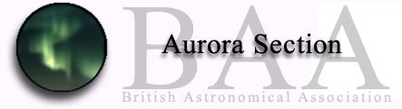
Moon:
Kp=

