.
Click on the empty fields to insert text.

When completed, save this form as a .doc or .pdf file with your name and date in the file name, and email it to Aurora and NLC Section Director, Sandra Brantingham, at sandra-b@hotmail.co.uk

Report for: | Year | Month | Night | Observer | Location

Additional Notes:
Date | Time  (UT) | Form | Brightness | Max. Elevation | Azimuth | Remarks

- NLC Report Form -

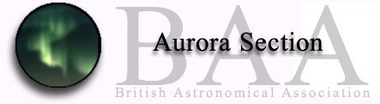
Moon:
Kp=

